|  |  |  |
| --- | --- | --- |
| **COMSATS University Islamabad**  **Sahiwal Campus** | | |
| **Department of computer science** | | |
| **Assignment # 1** | | |
| **Subject:** Programming Fundamentals | **Couse code:** CSC103 | **Due date:** 28/02/2024 |
| **Instructor:** M. Khurram Sissar | **Class:** fa23-BCS-E | **Total marks:** 30 |

Note: You need to develop and run these programs of your own. I may conduct viva/quiz to verify if programs are actually written by you. Failure to show understanding of code, copied assignment and code written using AI tools will yield 0 marks.

1. Write a C++ program that input a number and tell if it’s even or odd.
2. Write a program that input 10 numbers and counts even and odd numbers out of them.
3. Write a C++ program to input 3 angles and check whether the triangle is Acute (All angles are less than 90°), Right Triangle (one angle is 90°) or Obtuse triangle(Has an angle more than 90°).
4. Write a program that input 3 numbers tell if these numbers are consecutive or not. (like 34,35,36 are consecutive but 23,25,26 are not because there should be 24 after 23 to be consecutive).
5. Write a C program to input all sides of a triangle and check whether triangle is valid or not. A triangle is invalid if you find any 2 sides whose sum is less then third side, otherwise valid.
6. Write a C++ program that input 5 numbers and find maximum between five numbers.
7. The BMI (Body Mass Index) measurement is used to access a person’s fitness based on his height and weight. BMI is calculated by dividing a person’s weight by the square of his/her height where weight and height must be in kilograms and meters.

**BMI = weight in kilograms / Height in meters**

Write a program in C++ that inputs weight in kg, height in inches, calculates BMI and display to user (you will need to convert height to meters before applying formula; 1 meter = 39.37 inches). Your program should additionally display user his status:

* If the BMI value is less than 18.5, the person is underweight.
* The value between 18.5 to 24.9 is optimal and indicates a healthy and normal.
* If the BMI value is between 25 to 29.9, the person is overweight.
* BMI values greater than 30 indicate obesity.

1. Write a C++ program to suggest change for the shopkeeper. It must show count total number of each currency notes in amount given by user considering notes of 1000, 500, 100, 50, 10 and coins of 5, 2, 1 .

Like in 1738, its 1 note of thousand, 1 note of 500, 2 notes of 100, 3 notes of 10, 1 coin of 5, 1 coins of 2 and 1 coin of 1.

1. Write a C program to input electricity units and calculate total electricity bill according to the given condition:

|  |
| --- |
| For first 50 units Rs. 0.50/unit |
| For next 100 units Rs. 0.75/unit |
| For next 100 units Rs. 1.20/unit |
| For unit above 250 Rs. 1.50/unit |
| An additional surcharge of 20% is added to the bill |

1. 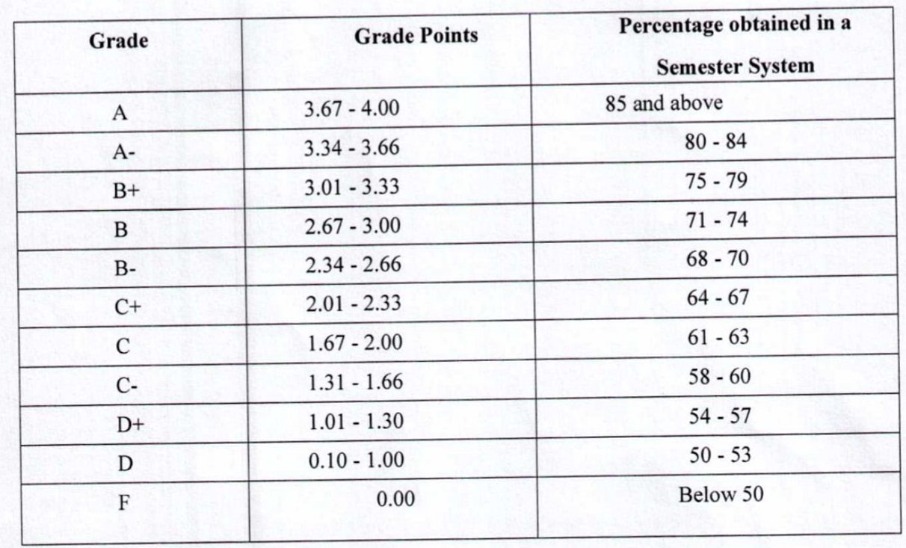Write a C++ program to input marks of subject and show grade(A to F) according to following: